Let’s Get Cooking!

Introduction
Fractions are a large part of baking. Ingredient measurements are often given in quarter cup increments. In fact, small measurements are sometimes given in eighths of a teaspoon. In order to successfully bake, it is important to be able to work with fractions. Recipes will need to be doubled or halved depending on the quantity that needs to be made. Baking, therefore, requires an understanding of fractions. When you can work effortlessly with fractions you have the skills to bake up whatever you are in the mood for. Who doesn’t like a warm chocolate chip cookie now and then?

Task
You are having a get together and are expecting 30 guests. You plan on serving Banana Bread, Chocolate Chip Cookies, and Sugar Cookies. Using the three recipes given, work with your group to create recipe cards to feed 30 people. Next, total up the ingredients needed. Then, check to see how much of each product needs to be purchased based on what is already on hand. Finally, create a display of your project that showcases your group’s creativity.

Instructions
Complete each problem in order. Be sure to keep careful notes and save your work as you progress. You will work together to create a display at the end of the project.

1. Use your knowledge of fractions to re-write the recipe for Banana Bread. The card states that it serves 10 people. What will need to be done in order to make enough bread for 30 people? Show your work neatly and then re-write the recipe card.

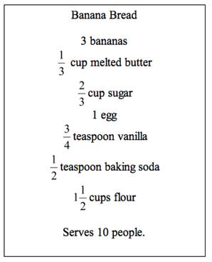

2. Use your knowledge of fractions to re-write the recipe for Chocolate Chip Cookies. The card states that it makes 60 cookies. What will need to be done in order to make 30 cookies? Show your work neatly and then re-write the recipe card.

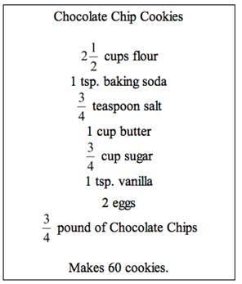

3. Use your knowledge of fractions to re-write the recipe for Sugar Cookies. The card states that it serves 20 people. What will need to be done in order to make enough to serve 30 people? Show your work neatly and then re-write the recipe card.

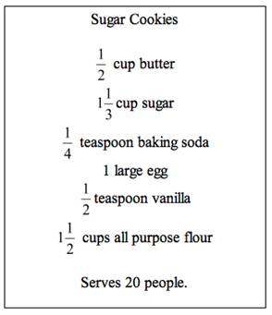

4. Use your new recipe cards to find the total amount of each ingredient needed. Use the table below to help you.

Ingredient | Recipe 1 + 2 + 3  (Don’t forget to find common denominators before adding.) | Total needed  (Be sure to simplify any fractions.)
Flour
Sugar
Butter
Vanilla
Baking Soda
Eggs
Salt
Chocolate Chips
Bananas

5. When taking inventory in the pantry, you found that you already have some of the ingredients. Use the following table to organize your work. Don’t forget common denominators.

HINT: If you need 5 eggs and you already have 2, how many do you need to buy? Write a number sentence to describe this situation. Which operation did you use? Use the same method to solve for the other ingredients. Don’t forget common denominators.

Ingredient | Total needed from above | Already in Pantry | Needs to be bought
Flour |  | cups
Sugar |  | 2 cups
Butter |  | cup
Vanilla |  | 2 teaspoons
Baking Soda |  | teaspoons
Eggs |  | 2
Salt |  | 1 teaspoon
Chocolate Chips |  | ¼ pound
Bananas |  | 4

Collaboration
Compare your three recipe cards with another group. The cards should look identical. If a measured ingredient varies, look at the work to determine where the error was made. Then compare the table with total ingredients. Again, the table should look identical. Compare your work to find any errors. Finally, compare the last table. Do the answers agree? Are all fractions simplified?

Conclusion
Create a poster to display your work. Include the three new recipe cards, as well as the math work done to figure each new amount. Then include the table with the ingredient totals and the table with the amount to be purchased. Again, include the math on the poster. Finally, incorporate pictures and color to the poster to create a professional looking product.

Grade
Your project will be given a score of 1 to 4, with 4 being the highest score possible. You will be evaluated based on the following criteria:

Score | Content | Presentation
4 | Your project appropriately answers each of the problems. Your mathematical calculations are set up and carried out properly. All fractions are simplified. | Your project contains information presented in a logical and interesting sequence that is easy to follow.  Your display includes attractive use of color and graphics.
3 | Your project appropriately answers each of the problems. Your mathematical calculations are for the most part set up and carried out properly. Minor errors may be noted. | Your project contains information presented in a logical sequence that is easy to follow.  Your display is neatly presented.
2 | Your project attempts to answer each of the problems. Some mathematical calculations are set up and carried out properly; however, major errors are noted on some calculations. | Your project is hard to follow because the material is presented in a manner that jumps around between unconnected topics.  Your display lacks a neat, orderly appearance.
1 | Your project attempts to answer only some of the problems. Major errors are noted on most mathematical calculations. | Your project is difficult to understand because there is no sequence of information.  Your display is hard to follow due to an overall illegible appearance.

